Control Budget

Team Members: Mudda Prabhakar Yashaswi (Marketing Lead)  
 V. Sai Kumar (Back End Developer)  
 P. Sunil (Front End Developer)  
 A. Srikar (Designer)   
 Gayatri (Back End Developer)  
  
  
  
**What is control budget ?**

It is a website which can be used by all age categories for tracking their expenses and controlling them accordingly.  
  
**How does it work?**

* The user initially signs in with his or her account. If he/she doesn’t have any he can sign up using their Google mail or Facebook ID.   
  The user can add the initial budget for the expenses and give it a title accordingly. He/she can add links to their expenses.  
  Using groups user can add bills under the given budget and track his/her expenses accordingly.  
    
  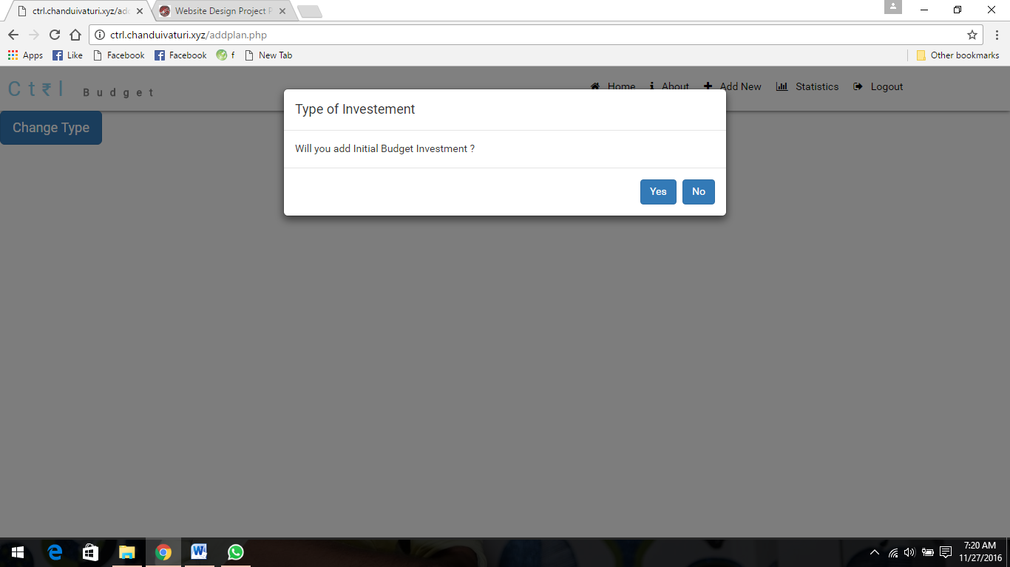  
    
  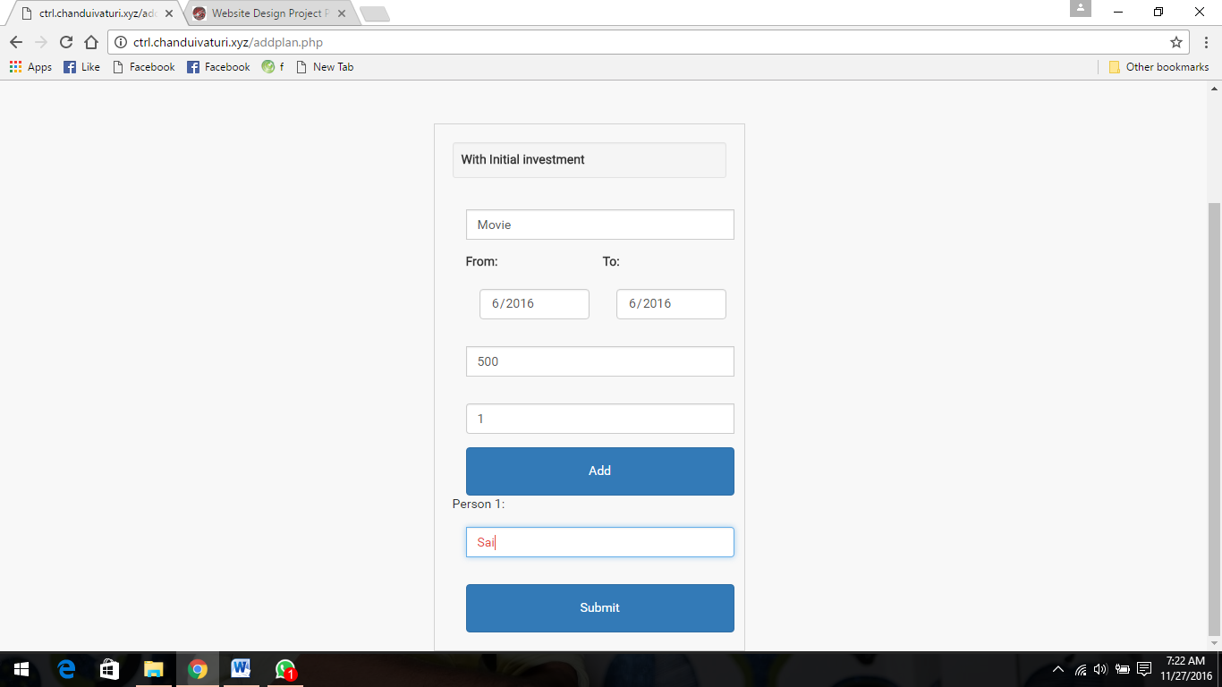  
    
    
  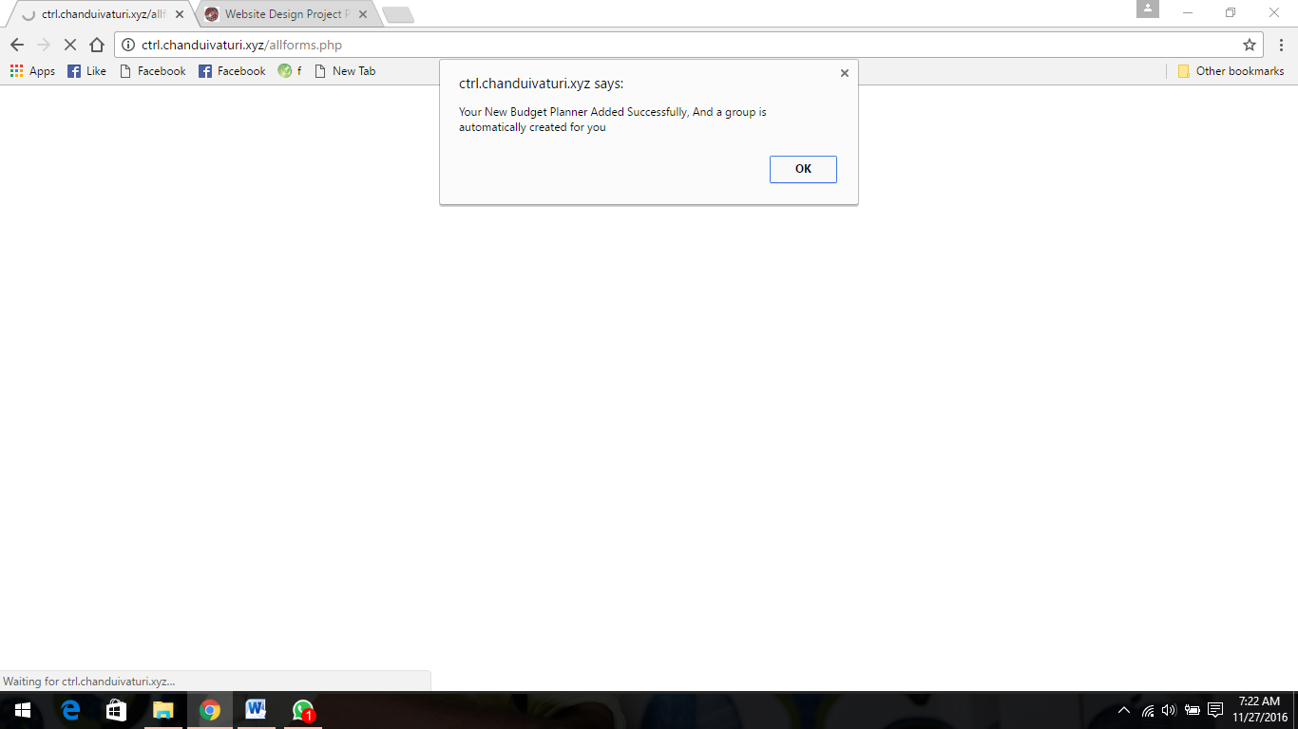  
    
    
    
  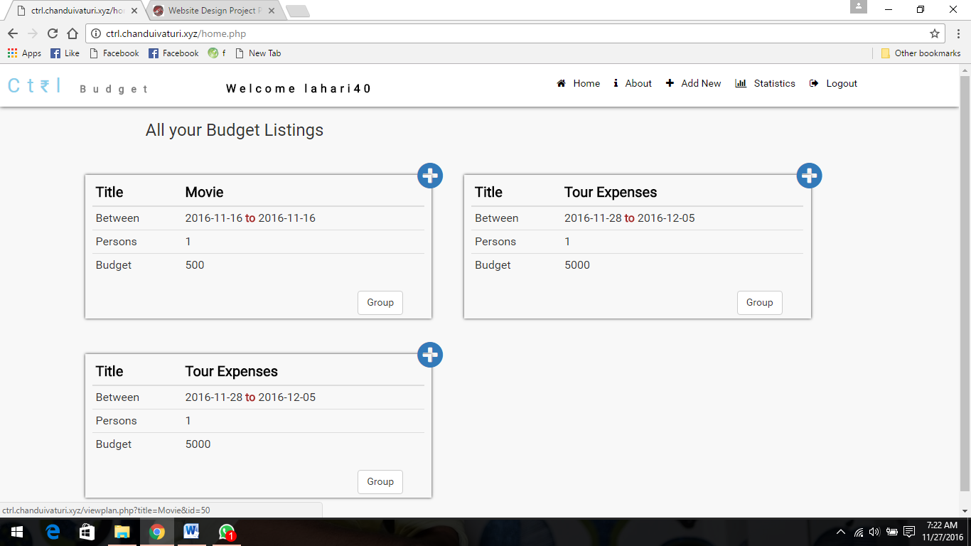  
    
    
  Now by clicking on the plus mark on the individual Budgets we can add our expenses.  
    
  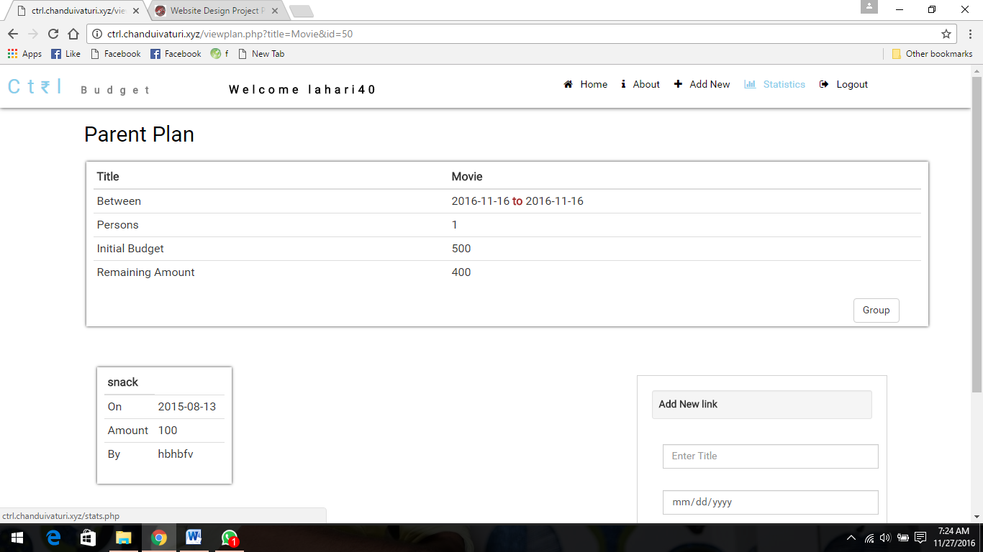  
    
    
  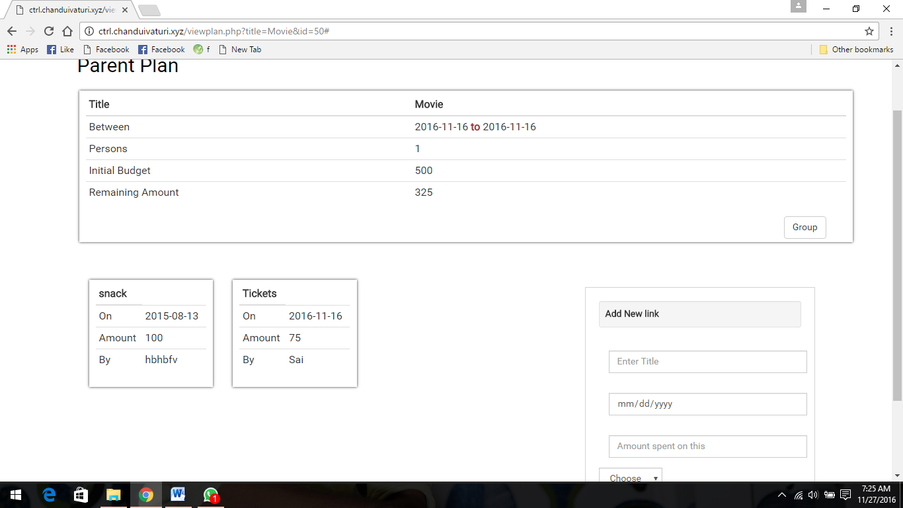  
   **Features**
* Track your expenses.
* Make budget plan.
* Add bills to your expenses and never fever of losing it.